**EXPERIMENT NO. 9**

**AIM:** To study the development of Drawings using 3D Scanner.

**THEORY:** 3D scanning is the process of analyzing a real-world object or environment to collect data on Its shape and possibly its appearance. The collected data can then be used to construct digital 3D models. In this process of obtaining the 3D shapes of the component whose physical attributes are difficult to measure, the scanning obtains the data in the form of point cloud data or triangular mesh, these point cloud form of data is used to create the 3D model of the component by using some CAD software A 3D scan is a three-dimensional image of part of an object’s surface. Sets of 3D scans form a 3D model. Just as 2D photos are made up of pixels, 3D scans are made up of tiny triangles, or polygons. Polygons form a polygonal mesh, which replicates the object’s geometry in minute detail.

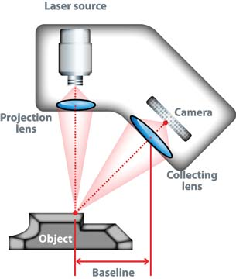

**Fig: 3 D Scanner**

**WORKING OF 3 D SCANNERS:** 3 D scanning techniques are of two types

1. Non contact type (Laser Scanning) 2. Contact type (Digitizing)

Laser scanning passes a laser line over the surface of an object. Surface data is captured by a camera sensor mounted in the laser scanner which records and saves three-dimensional information to a model. Regions of an object are scanned at once, allowing hundreds or thousands of closely positioned points to be surveyed at once. Several types of laser scanners exist, including line, patch, and spherical. Laser scanning is performed without making contact with the object.

Digitizing is a contact based form of 3D scanning in which a point or ball probe is scanned over points on the surface of an object to record geometrical position information. Digitizing is more accurate for industrial reverse engineering applications when precision of a complex part is desired, whereas 3D laser scanning is far more desirable for non-standard or organic shapes such as sculptures or a person’s face. Digitizing is often limited to smaller objects, while 3D laser scanning is more versatile, and can be used to scan large objects, such as vehicles or buildings. White light scanning, CT scanning and photo image based systems are alternate methods that are being used for 3D scanning applications

**ADVANTAGES OF 3 D SCANNING:**

* Quickly capture all of the physical measurements of any physical object
* Save time in design work
* Ensure parts will fit together on the first try
* Capture engineering optimizations inherent in manufactured parts
* Utilize modern manufacturing on parts that were originally manufactured before CAD
* Compare “as-designed” model to “as-built” condition of manufactured parts

**LIMITATIONS OF 3D SCANNING:**

* Bright white light sources can be detrimental to 3D scanning technologies, requiring many outdoor laser scanning projects to be conducted after daylight hours.
* 3D scanning works better on matte finishes than highly reflective surfaces, which reflect white light. Spray on solutions exist that can effectively dull a surface prior to scanning.
* Some intricate objects, such as large sculptures, require the use of stationary and handheld scanners to reconstruct the entire surface. This process requires detailed and intricate image and position registration – fortunately, many companies exist that have mastered this process and provide solutions for these difficult problem.

**APPLICATIONS OF 3D SCANNERS:**

3 D Scanners are used in a range of industries, from manufacturing to healthcare and VR. Retrofitting heavy machinery, performing quality control of mechanical parts, designing customized prosthetic devices, creating visual effects for movies, developing characters for video games etc.